**JPEG Compression Explanation**

JPEG => JPEG stands for Joint Photographic Experts Group.

Lossy Compression Algorithm that results in significantly smaller file sizes with little to no perceptible impact on picture quality and resolution.

**JPEG Compression Steps:**

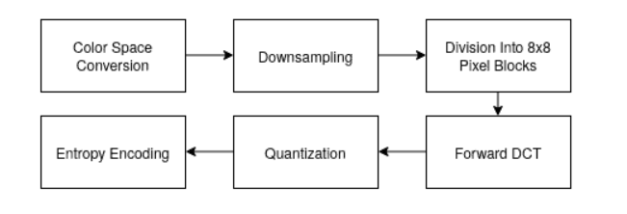

The above steps result in a .jpg image file.

**Step1. Color Space Conversion:** like RGB, Gray scale, CMYK and more. JPEG changes color space to YCbCr.

**Step 2. Downsampling:** JPEG downsamples the chrominance channels to a quarter of their original size. Each block of 4 pixels is averaged into a single color value for all 4 pixels. As a result, some information is lost, and the size of the picture is halved.

**Step 3. Division into 8X8 Pixel blocks:** After downsampling, the pixel data of each channel is divided into 8×8 blocks of 64 pixels. From now on, the algorithm processes each block of pixels independently.

**Step 4. DCT(Discrete Cosine Transform):** Using [DCT](https://en.wikipedia.org/wiki/Discrete_cosine_transform), for each channel, each block of 64 pixels can be reconstructed by multiplying a constant set of base images by their corresponding weight values and then summing them up together.

**Step 5. Quantization:** Using [DCT](https://en.wikipedia.org/wiki/Discrete_cosine_transform), for each channel, each block of 64 pixels can be reconstructed by multiplying a constant set of base images by their corresponding weight values and then summing them up together.

**Step 6. Entropy Encoding:** Run Length Encoding and Huffman Coding Algorithm.